**Lab 1**

**Introduction to Unity and a simple 2D game**

1. Hello Unity

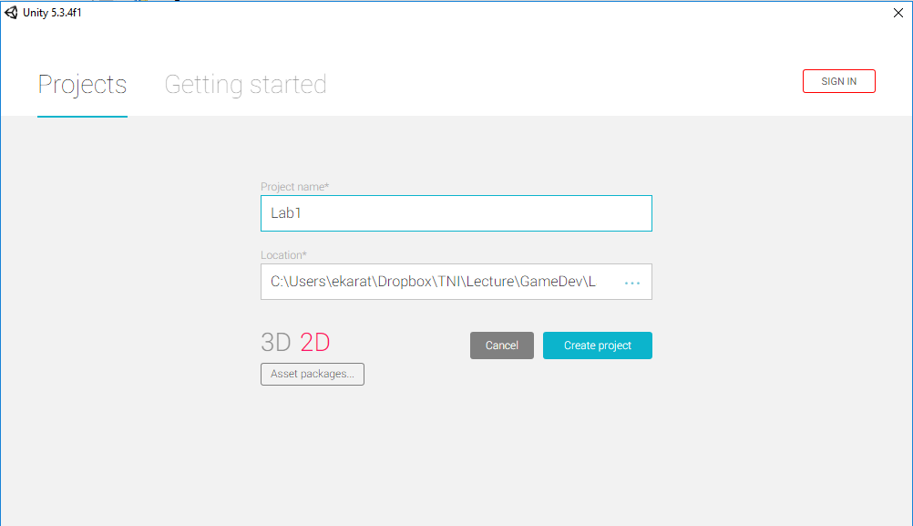

1. An overview of Unity’s User Interface

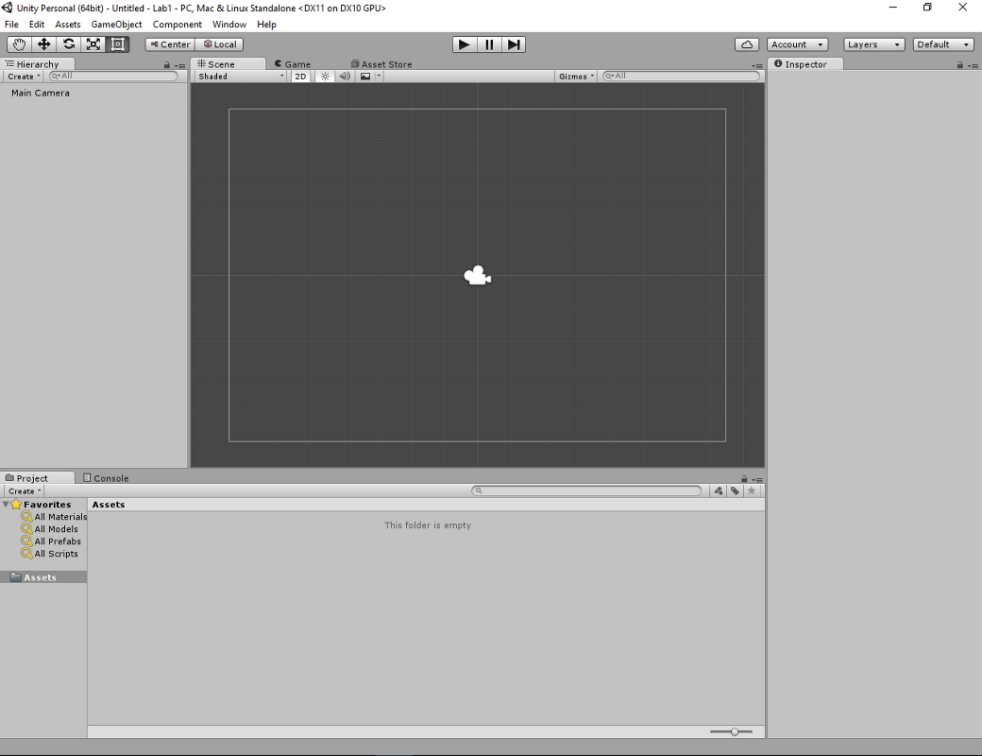

1. Creating assets
   1. Save scene as “Scene1”
   2. Sprite:
      1. Right click on Project panel
      2. Choose: create > sprites > square
   3. C# script:
      1. Right click on Project panel
      2. Choose: create > C# Script (named it as Main.cs)

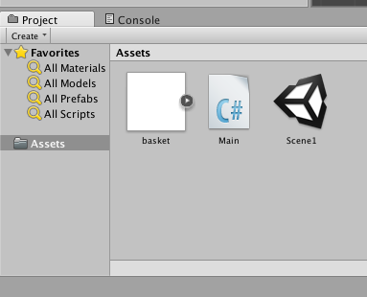

Example of C# code

using UnityEngine;

using System.Collections;

public class Main : MonoBehaviour {

// Use this for initialization

void Start () {

}

// Update is called once per frame

void Update () {

}

}

1. Control sprite in game
   1. Move sprite to the right of x-axis
   2. Explain about update system
   3. Vector 2D

using UnityEngine;

using System.Collections;

public class Main : MonoBehaviour {

// Use this for initialization

void Start () {

}

// Update is called once per frame

void Update () {

transform.position += new Vector3(1.0f * Time.deltaTime, 0, 0);

}

}

1. Input

void Update () {

if (Input.GetKey ("left"))

{

transform.position -= new Vector3 (1.0f * Time.deltaTime, 0, 0);

}

else if (Input.GetKey ("right"))

{

transform.position += new Vector3 (1.0f * Time.deltaTime, 0, 0);

}

   else if(Input.GetKey(KeyCode.A)) //Rotate  
        {  
            transform.Rotate(0,0, Time.deltaTime * 10);  
        }  
        else if(Input.GetKey(KeyCode.S)) //Scale  
        {  
            transform.localScale = new Vector3(2, 2,0);          
  
        }

}

1. Delete game object

Destroy (this.gameObject);

1. Prefab

Asset type that allows you to store a GameObject object complete with components and properties. The prefab acts as a template from which you can create new object instances in the scene.

using System.Collections;  
using System.Collections.Generic;  
using UnityEngine;  
  
public class MainGame : MonoBehaviour {  
  
    public GameObject gameObject;  
  
    *// Use this for initialization*  
    void Start () {  
        Instantiate (gameObject);  
    }  
      
    *// Update is called once per frame*  
    void Update () {  
          
    }

1. Review C#
   1. Data type (int, float, double)
   2. Random
   3. String
   4. Array
   5. Data structure (List, Queue, etc…)

Exercise

1. Instantiate array of five game objects (g) randomly.
2. Create animation for each g to move down with randomly speed.
3. Control square to keep all g, after each square hit each g, g is removed.